Changing Network card speed in Windows 2000 and XP
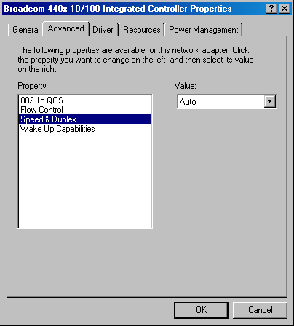
Changing the Nic card speed Windows 2k and XP is fairly easy. You start by going to the properties of the local area connection. This is done in Windows 2000 by the following. Start>Settings>Control Panel>Network and dial up connections. In Windows XP do the following. Start>Settings>Control Panel>Network connections.

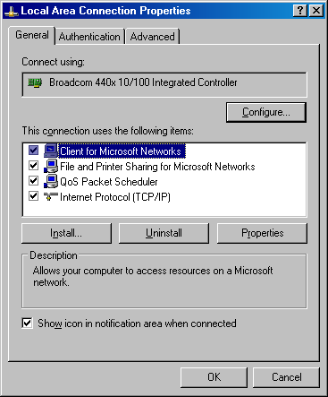

Once on the properties of the local area connection you need to click on the Configure button.
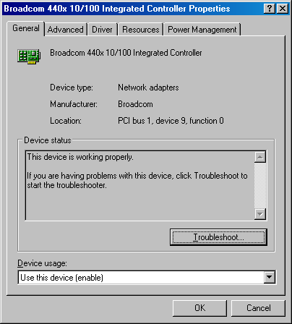

Now you have the guest go to the advanced tab.
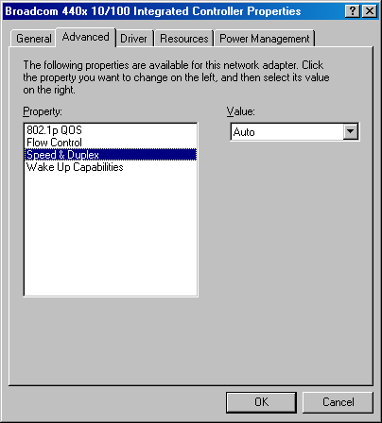
Now you need to look for the Speed and Duplex under the Property area and highlight it. Under the value area it drops down to show the following.
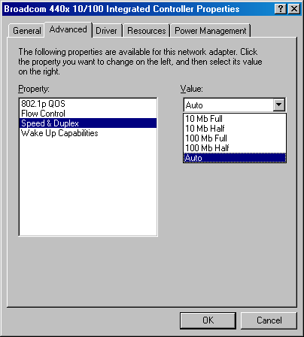

NOTE: Not all network cards will have it listed as Speed and duplex or have the same menu on the Value side. The following is a list of some of the network cards that you will come across and the way these card show the link speed and duplex area:

Accton – media type or link speed
Broadcom – speed and duplex
Xircom – line configuration or both line speed and line mode
Intel – link speed and duplex
SISS or 3Com – media type or network link selection
Realtek – link speed duplex mode
Nat Semiconductor – link speed and duplex or network media
Netgear – connection type
IBM – line mode and line speed
D-Link - Connection Type

